Manual for running the ThreeME model for results in paper “Macroeconomic Impact of Climate Damage in France”
Preparation
- Download Eviews, and make sure that you have a license.
- Make sure you have a github account and take the model from
  - https://github.com/ThreeME-org/ThreeME_V3-open
  - Branch: FRA-DAMAGE-INSEE-ES2024
  - More information on using the model – besides this document – is given under the folder ‘doc’.
- Make sure that Eviews knows your working directory
  - Open Eviews, go to options in the taskmenu, click on general options. Go to ‘file locations’, and make sure that the model knows where to find the model (“current data path”)
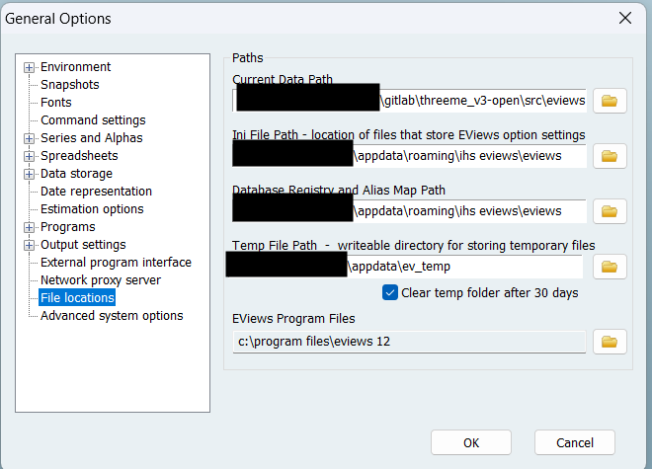
Run the model
- Open software program Eviews.
- Open file scr/Eviews/main.prg, via File à open à Programs.
- Run this file. (Press run in the upper left corner.)
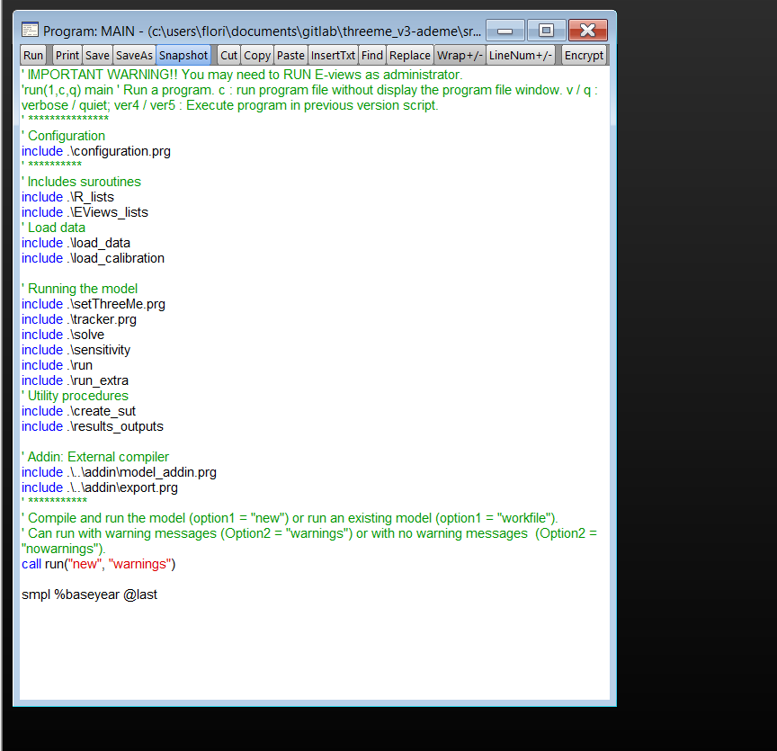

- A first window opens and asks for a name for the model you are launching — simply keep “a_3ME” and click OK.
- A second window appears with a warning about an accounting disequilibrium — click No to proceed with the simulation.
- A third window then asks for a name for the results — keep “a_3ME_res” and click OK. This creates a new workfile with the data of the model and an Excel file “DATE_Results_France.xlsx” in the folder “results”
This Excel file contains the final results presented in the paper.

